- Try Test-Connection and nslookup commands for below websites
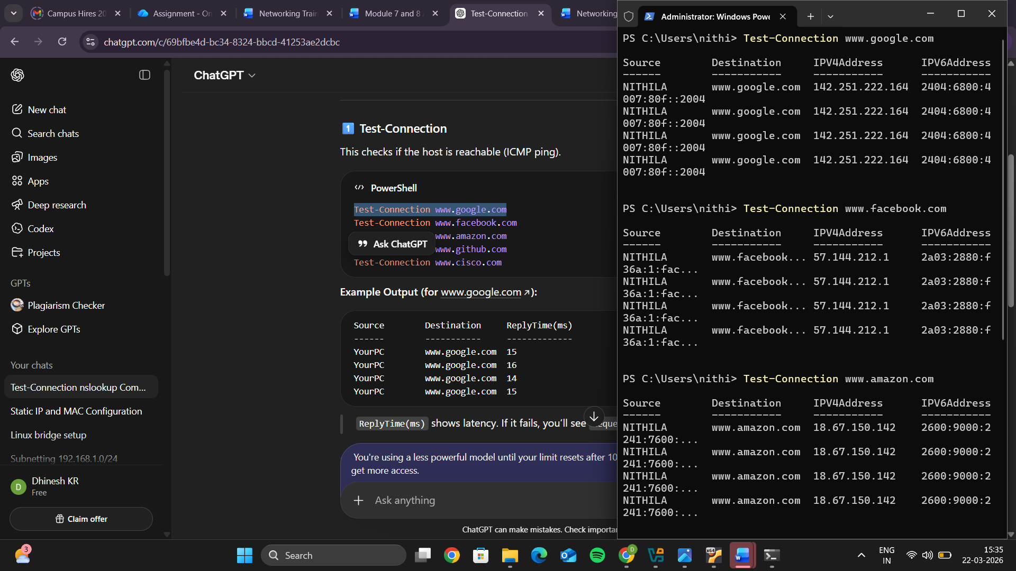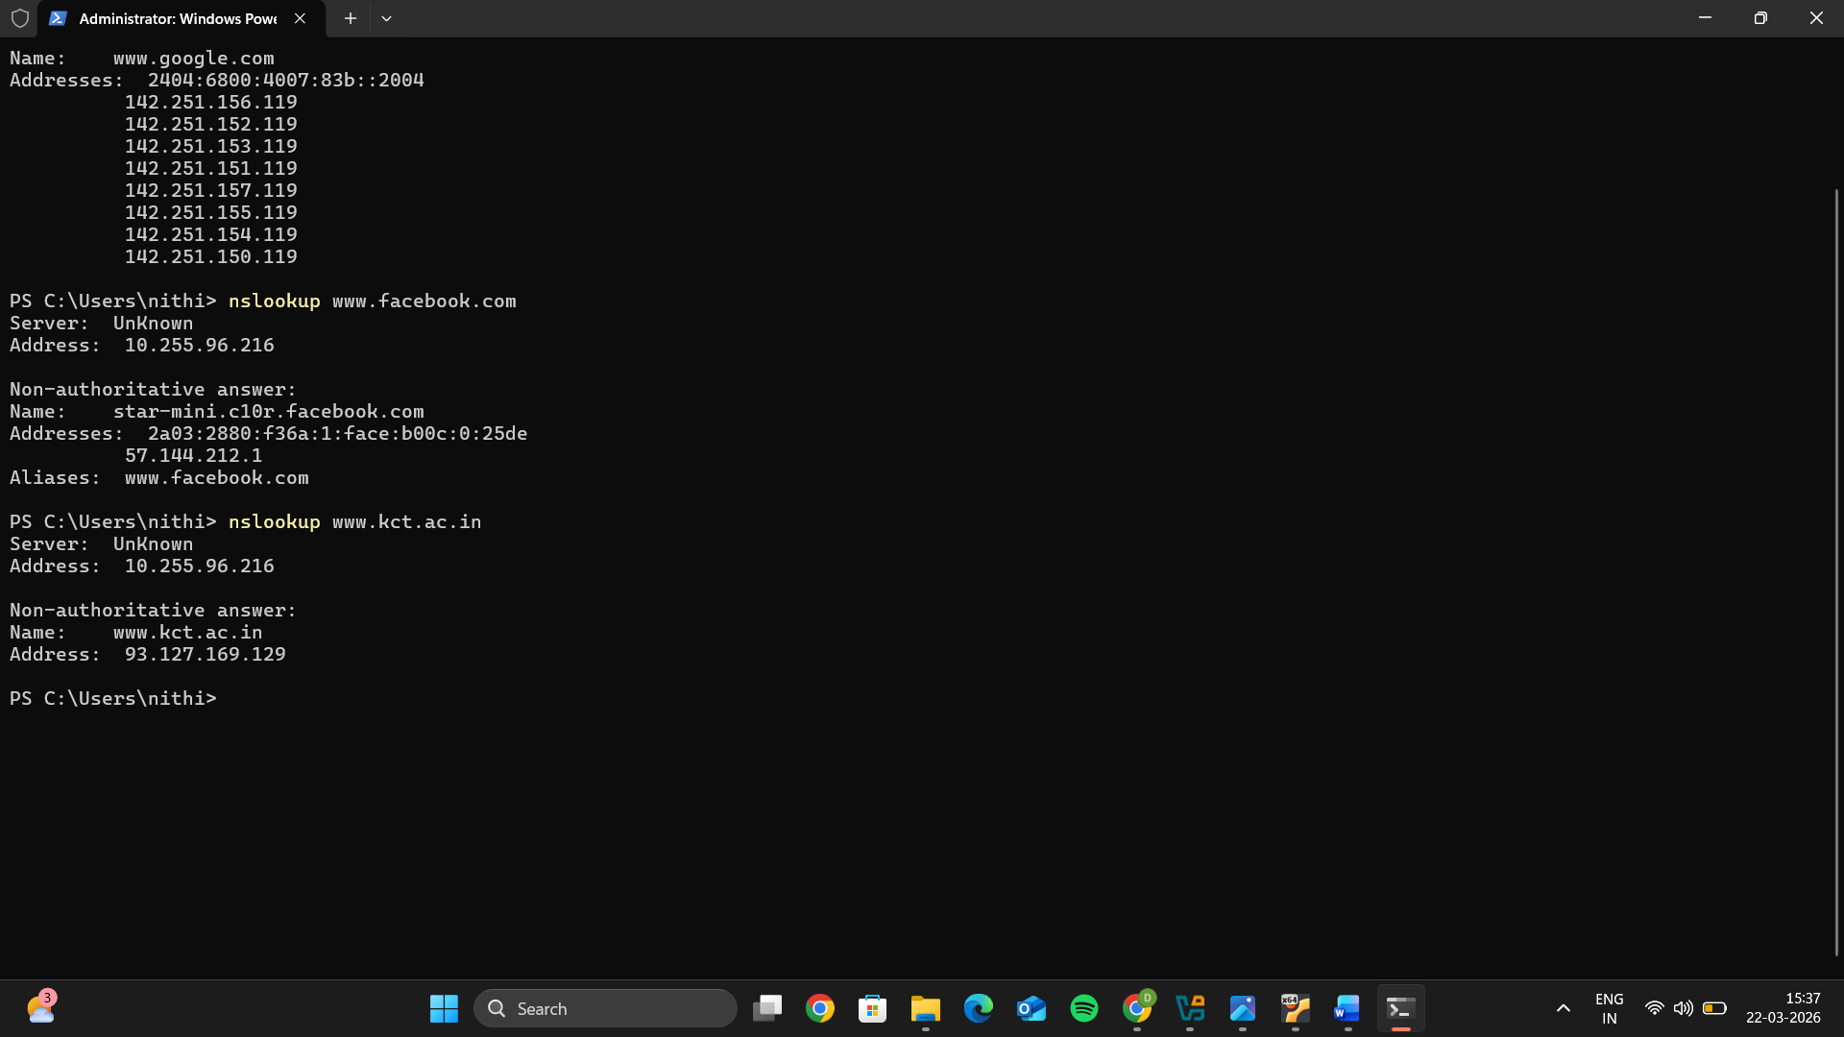
Command | Purpose
Test-Connection | Checks reachability and latency
nslookup | Finds the IP address of the domain and checks DNS resolution

- Use Wireshark to capture and analyze DNS, TCP, UDP traffic and packet header, packet flow, options and flags
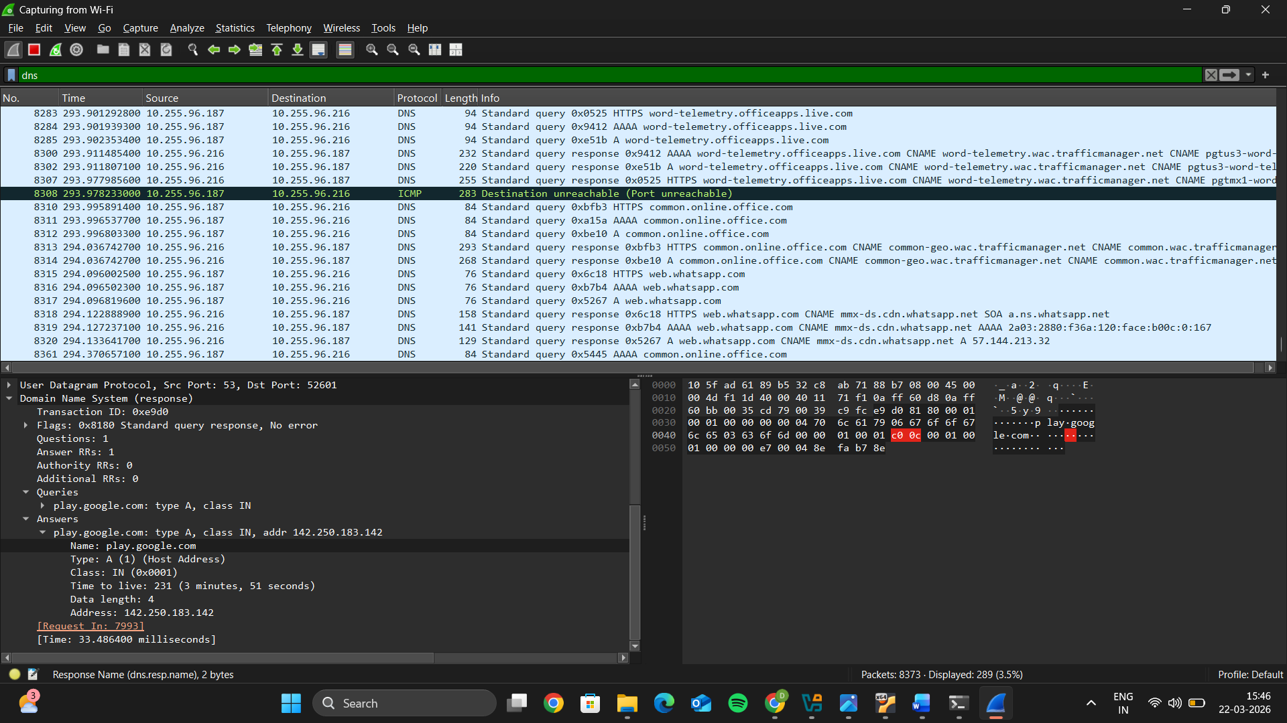 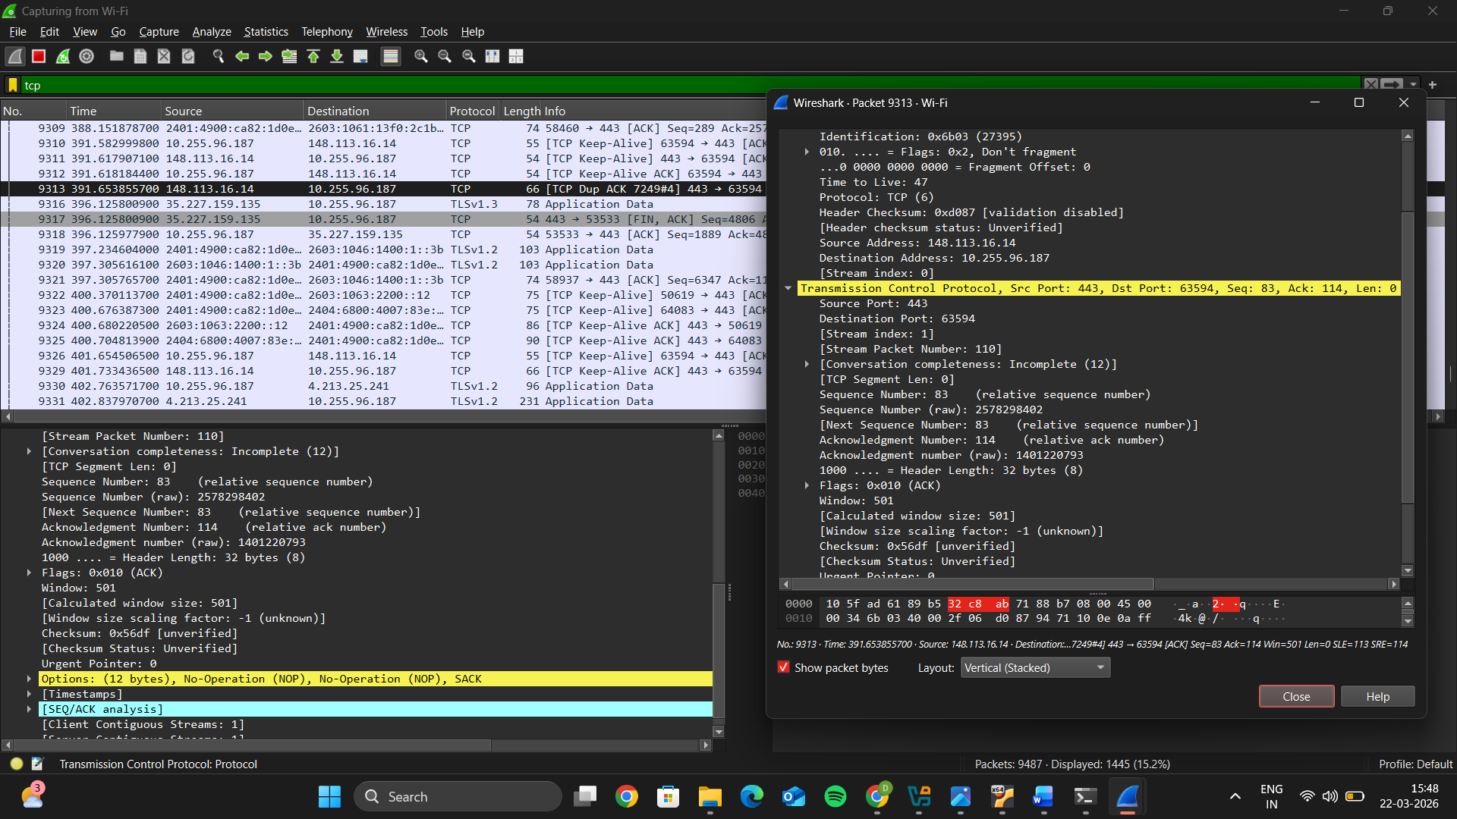 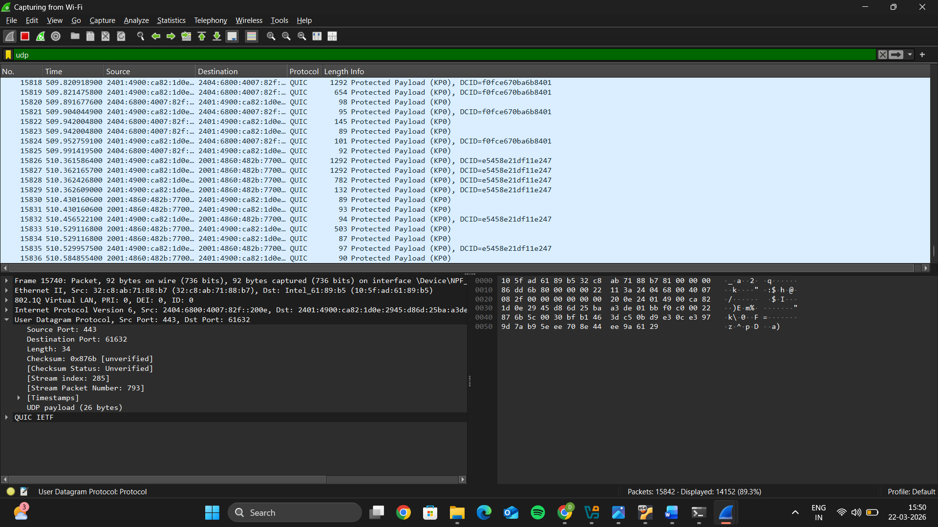

- Explore traceroute/tracert for different websites eg:google.com and analyse the parameters in the output and explore different options for traceroute command
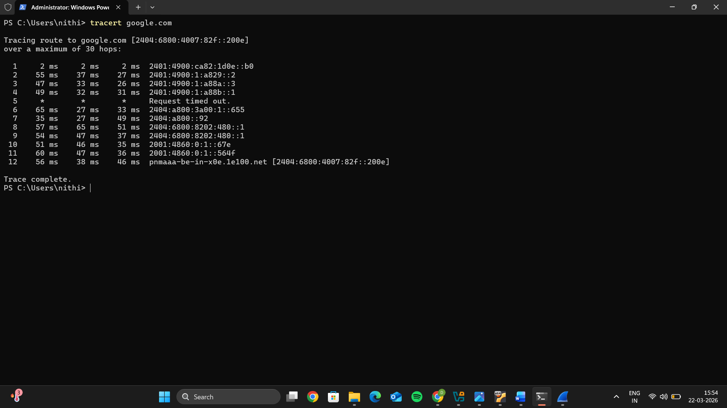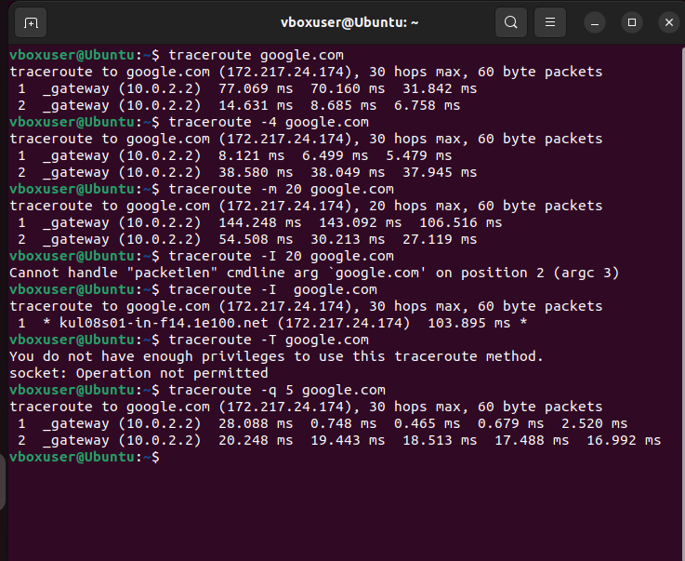
4. Use Cisco packet tracer for the below
- Set up trunk ports between switches and try ping between different VLANs.
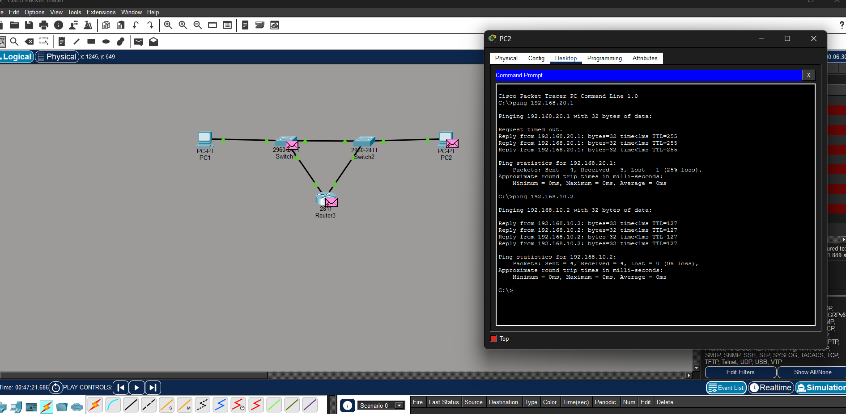

- Change the native VLAN on a trunk port. Test for VLAN mismatches and troubleshoot:
Native VLAN = traffic sent without tagging
Default = VLAN 1
You changed it to VLAN 99 on one side
What is VLAN Mismatch?
👉 When:
Switch1 native VLAN = 99
Switch2 native VLAN = 1
🚫 Both ends don’t agree → mismatch
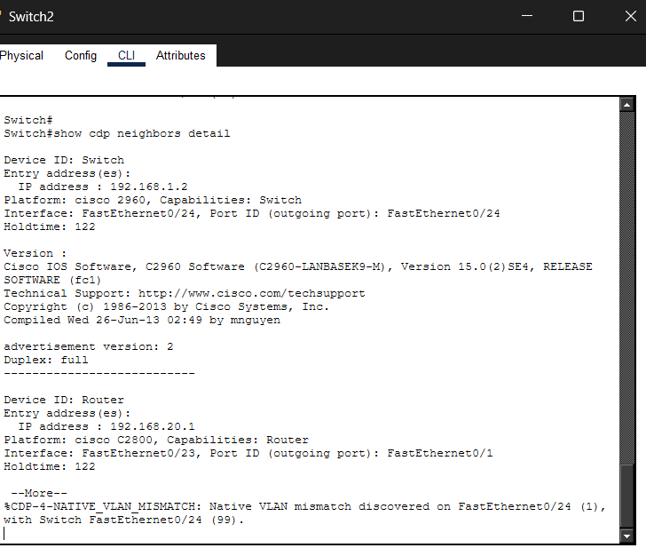
- Configure a management VLAN and assign an IP address for remote access.Test SSH or Telnet access to the switch.

8) You have a Cisco switch and a VoIP phone that needs to be placed in a voice VLAN (VLAN 20). The data for the PC should remain in a separate VLAN (VLAN 10) Configure the switch port to support both voice and data traffic.
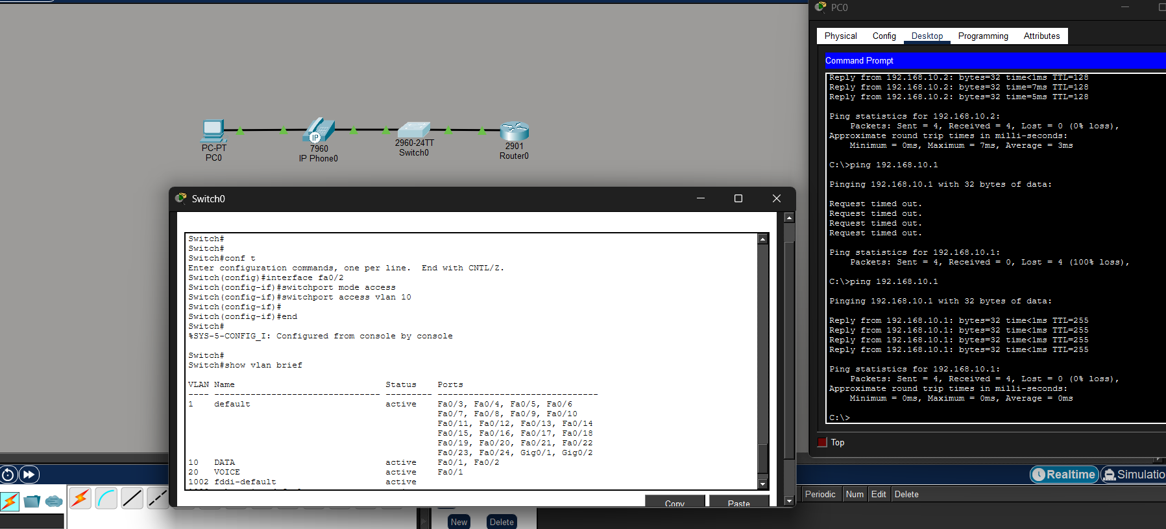

9) You configured VLANs 10 and 20 on your switch and assigned ports to each VLAN. However, devices in VLAN 10 cannot communicate with devices in VLAN 20, Troubleshoot the issue.
Understand the issue
- VLANs are separate networks → no communication by default
Check VLANs
- Use show vlan brief
- Ensure ports are in correct VLANs
Verify port mode
- Ports must be in access mode
- Correct VLAN assigned
Check IP configuration
- VLAN 10 → 192.168.10.x
- VLAN 20 → 192.168.20.x
Root cause
- No inter-VLAN routing (Layer 2 switch limitation)
Fix
- Use router or Layer 3 switch
- Configure trunk + router subinterfaces
Set default gateway
- VLAN 10 → 192.168.10.1
- VLAN 20 → 192.168.20.1
Test
- Ping within VLAN → then across VLAN
Therefore, Key point: Inter-VLAN communication requires a Layer 3 device.
10) Try Inter VLAN routing with Router:
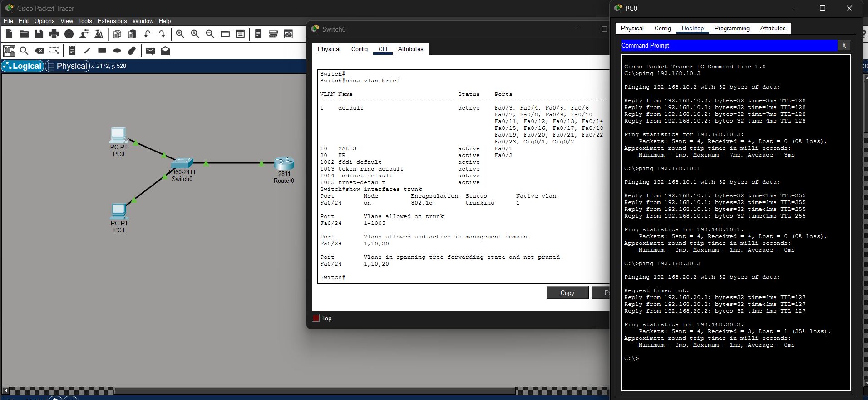

11) Implement ACLs to restrict traffic based on source and destination ports.Test rules by simulating legitimate and unauthorized traffic.
Create Extended ACL (on Router)
enable
configure terminal
access-list 100 permit tcp 192.168.10.0 0.0.0.255 192.168.20.0 0.0.0.255 eq 80
access-list 100 deny ip any any
Explanation
- permit tcp → allows only TCP traffic
- eq 80 → only HTTP allowed
- deny ip any any → blocks everything else
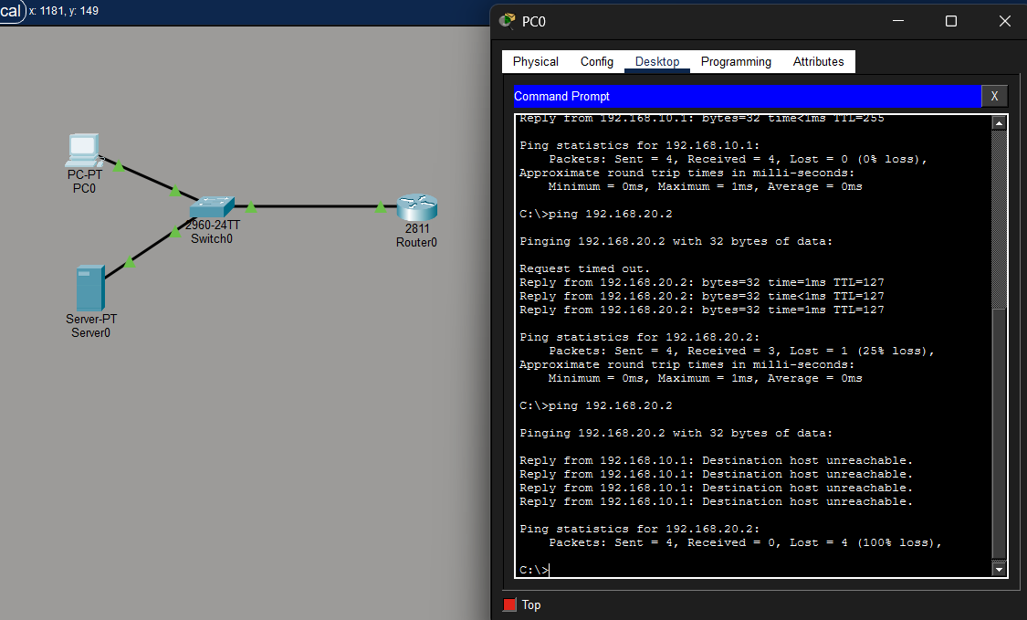

12) Configure a standard Access Control List (ACL) on a router to permit traffic from a specific IP range.Test connectivity to verify the ACL is working as intended.
- Permit traffic only from a specific IP range
- Block all other traffic
1. Scenario
- Allowed network → 192.168.10.0/24
- Destination network → 192.168.20.0/24
2. Configure Standard ACL
enable
configure terminal
access-list 1 permit 192.168.10.0 0.0.0.255
access-list 1 deny any
3. Apply ACL to Interface
Apply close to destination (important for Standard ACL)
interface g0/0.20
ip access-group 1 out
Explanation
- Standard ACL filters based only on source IP
- Only VLAN 10 network is allowed
- All other networks are denied
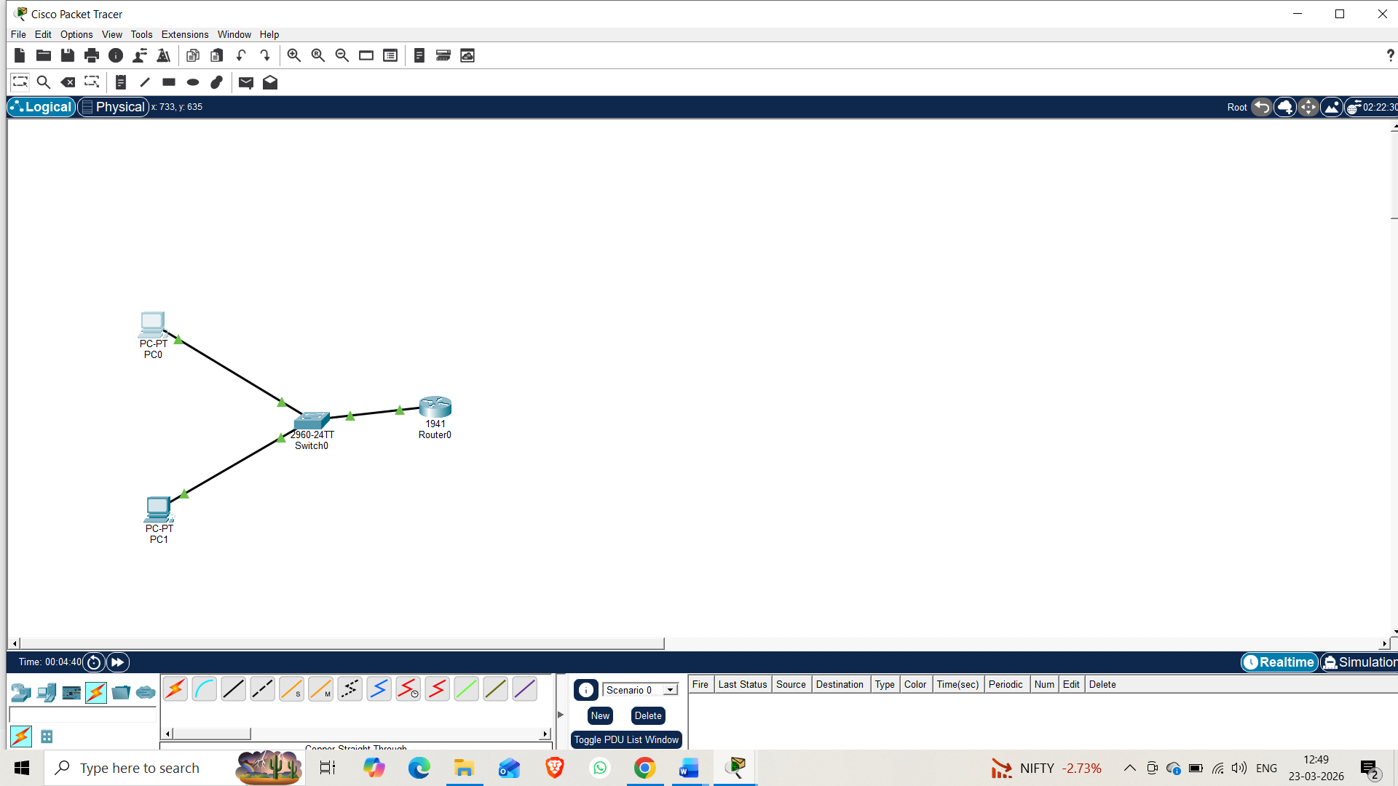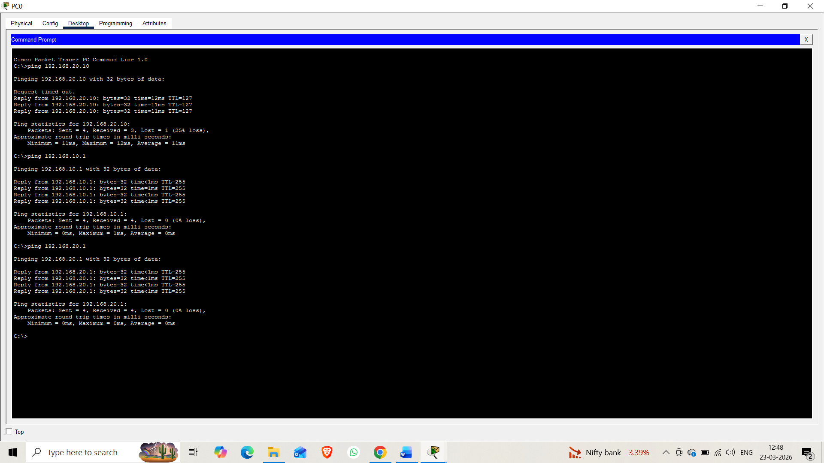
13) Create an extended ACL to block specific applications, such as HTTP or FTP traffic.Test the ACL rules by attempting to access blocked services.

14) Try Static NAT, Dynamic NAT and PAT to translate Ips
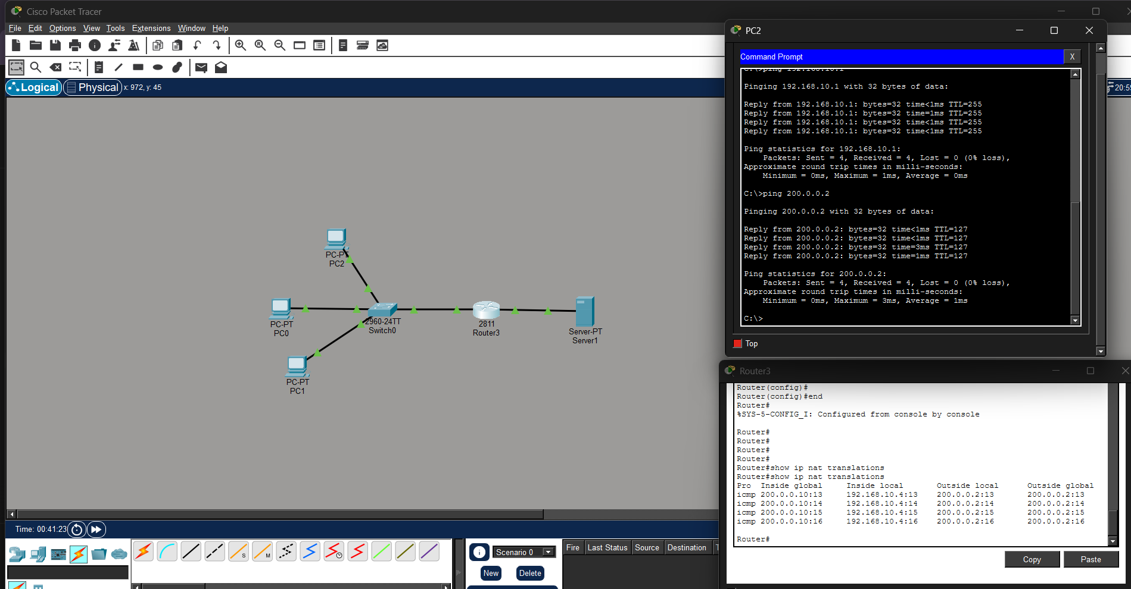
15) Download ipert in laptop/phone and make sure they are in same network. Try different iperf commands with top, udp, birectional, reverse, multicast, parallel options and analyze the bandwidth and rate of transmission, delay, jitter etc.
